AI StudyBuddy
Empathy Map Canvas
Design Thinking Phase

Project | AI StudyBuddy
PROJECT ID | SWTID-2026-7764
Prepared | 28 September 2026
Source | Current source folders: backend/ and client/
Document status | Project-specific draft based on current backend/client source evidence

Evidence baseline: current source files inspected from the backend/ and client/ folders. node_modules were not required. Claims not visible in source are labelled as implemented, partially implemented, proposed, unverified, or requiring verification.

Document Contents
- Primary Persona: University Student
- Empathy Map
- Secondary Persona: Administrator

Primary Persona: University Student
Says | Thinks | Does | Feels
“I have too much material to revise.” “Can I get the key points?” | Which topics matter most? Will the generated answer be useful? | Uploads files, requests summaries, opens flashcards and quizzes, creates tasks and notes. | Pressed for time, motivated by quick feedback, concerned about preparation quality.

Empathy Map
Area | Evidence-led interpretation
Sees | A landing page, authentication screens, glassmorphic dashboard, materials cards, AI assistant, quiz, planner, notes, and progress views.
Hears | Course explanations, peer study advice, and reminders to practise rather than only read.
Thinks and feels | Wants confidence, clarity, and a lower-effort route from raw material to revision.
Says and does | Uploads PDF/TXT/MD, requests AI outputs, flips cards, answers quizzes, and marks tasks complete.
Pains | Manual note processing, scattered learning tools, uncertainty about what to revise, limited time.
Gains | Fast summaries, active recall assets, study planning, and a visually engaging workspace.

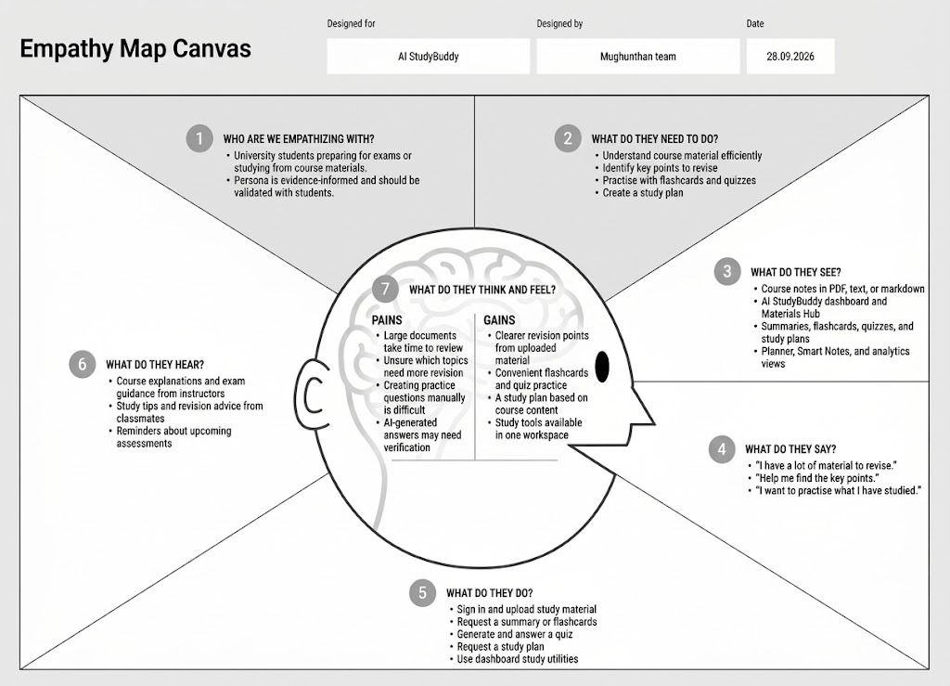

Secondary Persona: Administrator
Area | Needs and product response
Goals | Know how many users and materials exist; remove a user and associated materials when required.
Pain points | Limited governance visibility because the selected client source has no verified admin panel.
Implemented response | GET /api/admin/users, GET /api/admin/stats, DELETE /api/admin/users/:id.
Open need | Verify the intended AdminPanel source/integration, then add an audit trail and stronger operational reporting.
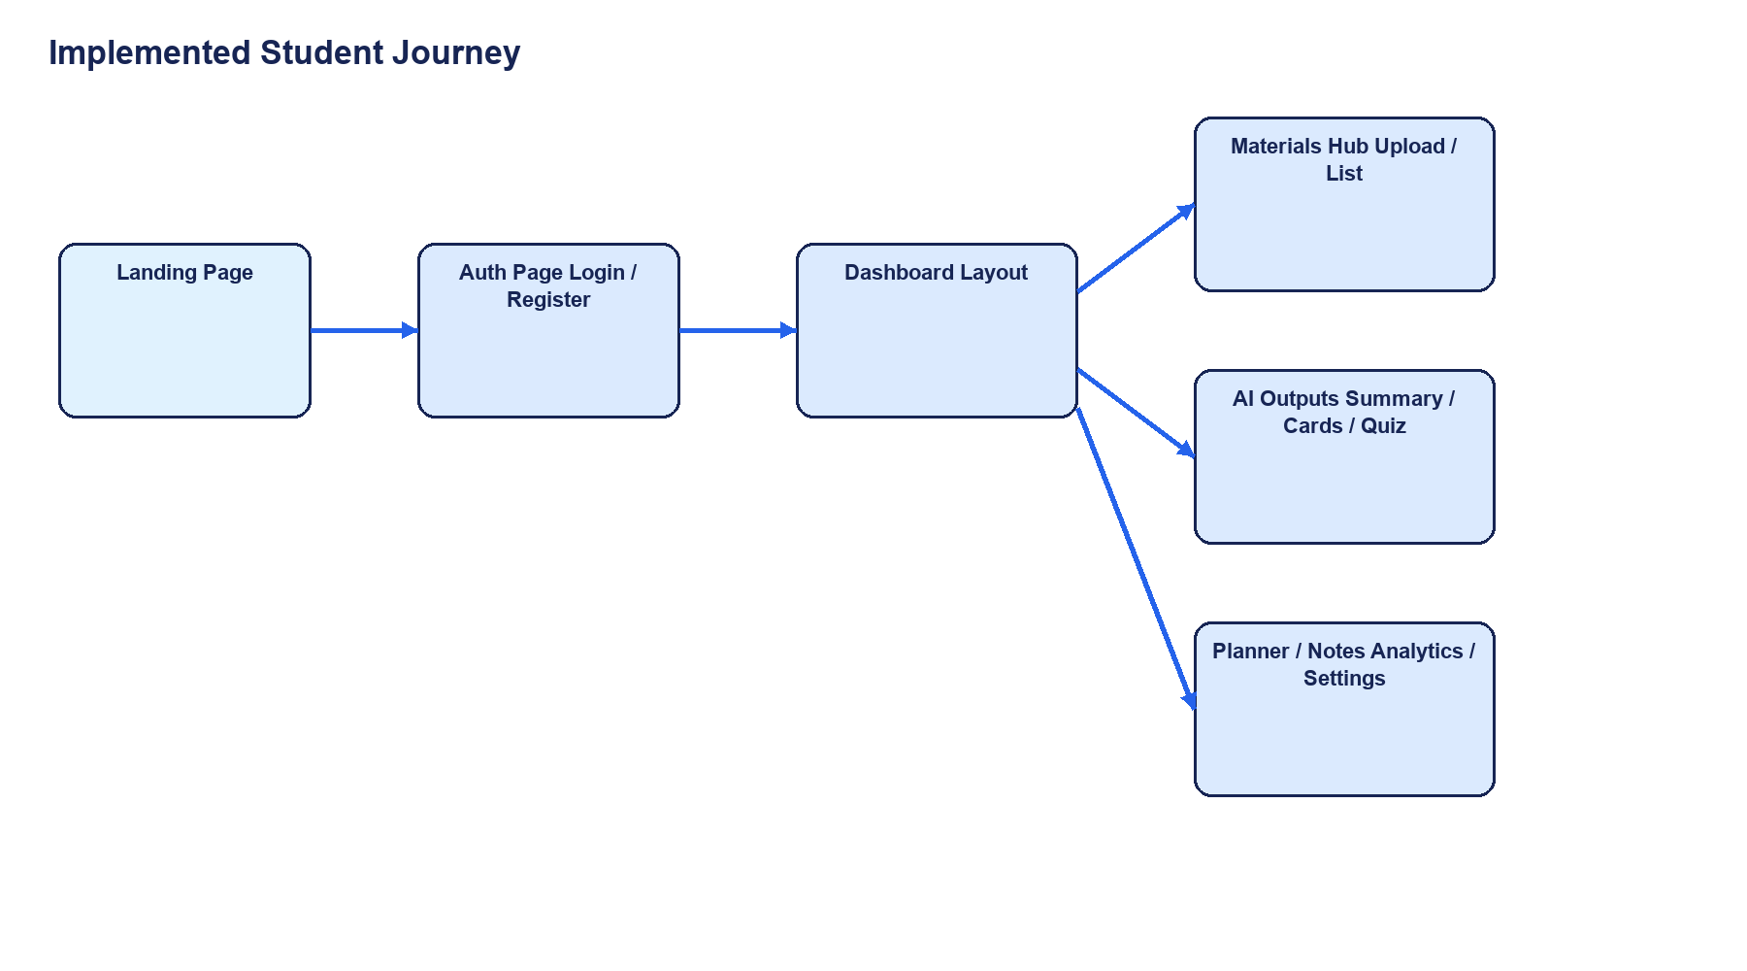
The implemented student journey connects landing, authentication, dashboard, materials, AI output, and study utilities.

